College of Education
Exam Analysis

Attached are the instructions on how to fill out your Exam Analysis. These are based on your Certify Teacher Exam mode (last attempt).
Go to your last exam on Certify Teacher. Scroll down to the bottom of the page. Click on then again scroll down to the bottom of the page and click on The following will appear:
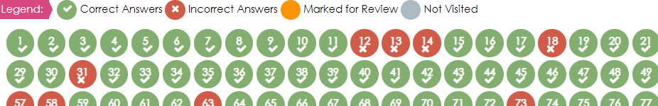


The green are correct answers and the RED ARE INCORRECT answers. Click on the red circle (one at a time) and the question followed by an explanation appears. Scroll down to the explanation section and use the information provided to complete the table. Please do not copy and paste information.
(Red Text is a Sample – You may Delete as you work on your Test Analysis)

Name: Exam: Last attempt Date:
Total # of Incorrect questions:

Question #, Domain, Competency | Skills Tested | Reason for Incorrect answer | Steps taken to Improve on Skill
#77  Domain: IV Fulfilling Professional Roles & Responsibilities  Comp: 011 Home/School/Community/Relations | The intent of the question is to determine whether the beginning teacher interacts appropriately with all families, including those that have diverse characteristics, backgrounds, and needs. | Below are some examples:  1. did not understand the voc/question  2. careless mistake  3. did not read all options  4. do not know enough about competency/domain | Below are some examples:  1. Did some online research on domain/competency  2. watched a youtube video on testing strategies  3. dedicated more daily time on studying

